Name: Bradley Willcott

ID: M198449

Date: 21 September 2021

Assessment Task – Project

Software Deployment

Contents

The Management Tools 3

Software Development Methodology 3

Waterfall 3

Project Management Software 3

RationalPlan Single 3

Source Control System 3

Git - GitHub 3

Collaboration Software 4

Trello 4

The Installation Package 7

Method of creation 7

Configuration 7

Deployment 8

System Requirements 8

Hardware 8

Software 8

Installation 8

Un-installation 12

References 15

Figures

Figure 1 - Trello: DVD Search App 4

Figure 2 - Trello: Using it - A 5

Figure 3 - Trello: Using it - B 5

Figure 4 - Trello: Using it - C 6

Figure 5 - Windows 10 Install 10

Figure 6 - Linux Install 11

Figure 7 - The pom.xml file - "maven-assemply-plugin" 13

# The Management Tools

## Software Development Methodology

### Waterfall

For such a small application, which has already *been* developed, the simple structured methodology of the WaterFall method seamed the most obvious choice.

## Project Management Software

### RationalPlan Single

A very featureful project planning software – that is **free**.

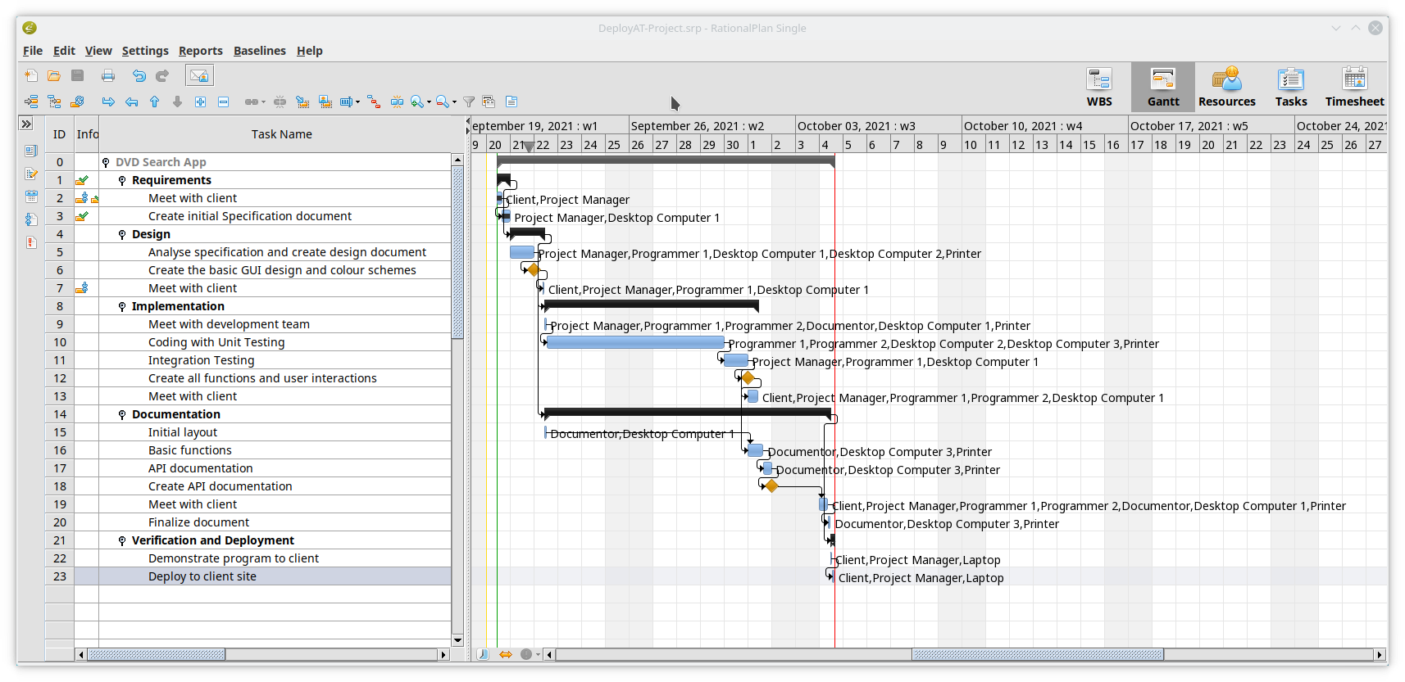

## Source Control System

### Git - GitHub

Very easy to use, is the latest option with the best features – its branching is to die for!

<https://github.com/bewillcott/DeployAT-Project>

## Collaboration Software

### Trello

I like the KanBan features of cards on a board. Very flexible. **Free**.

<https://trello.com/b/EjPqPsdF/dvd-search-app>

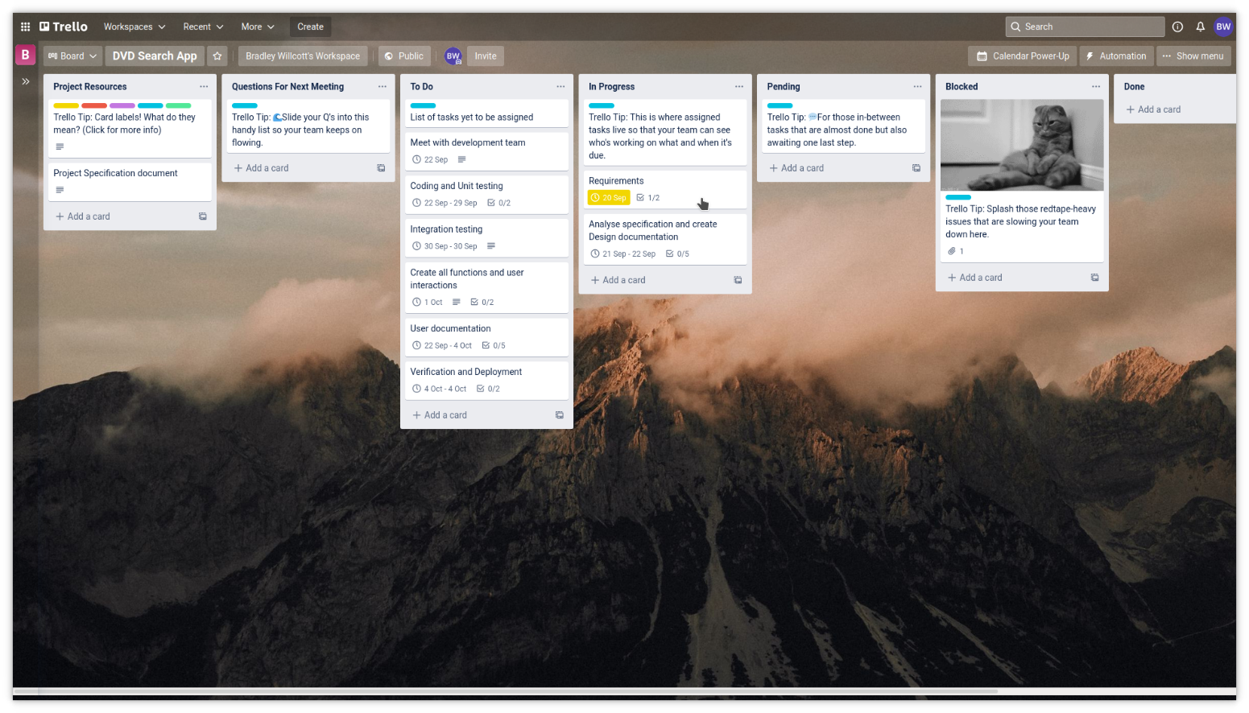

Figure 1 - Trello: DVD Search App

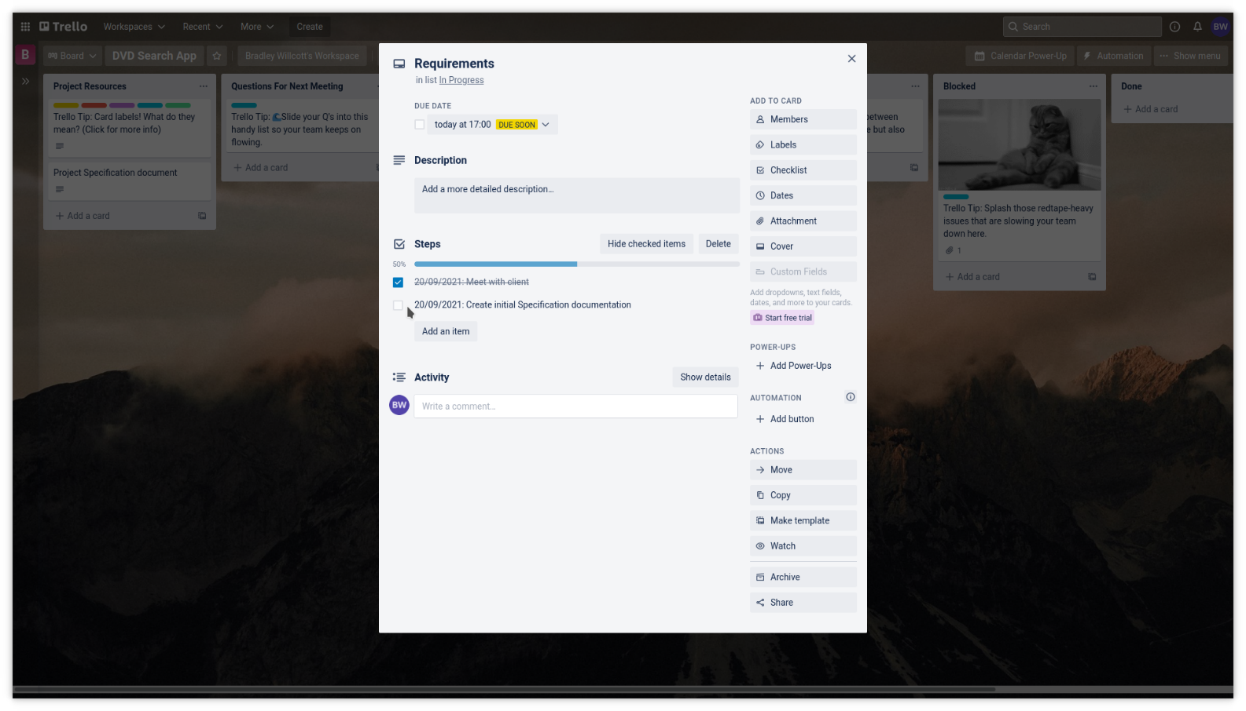

Figure 2 - Trello: Using it - A

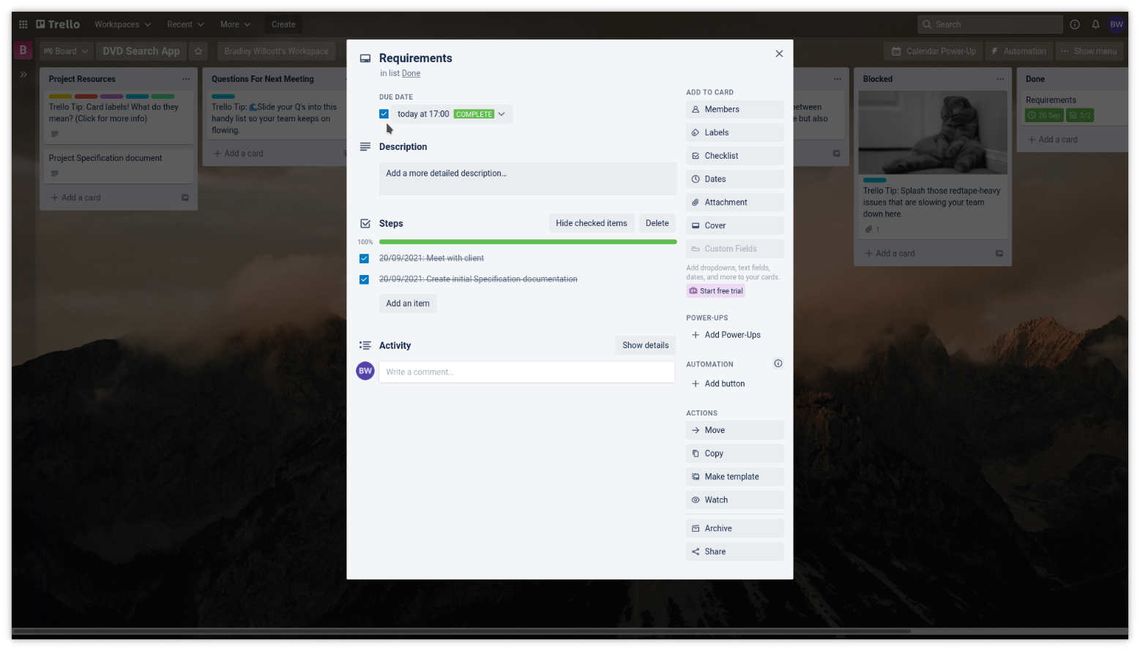

Figure 3 - Trello: Using it - B

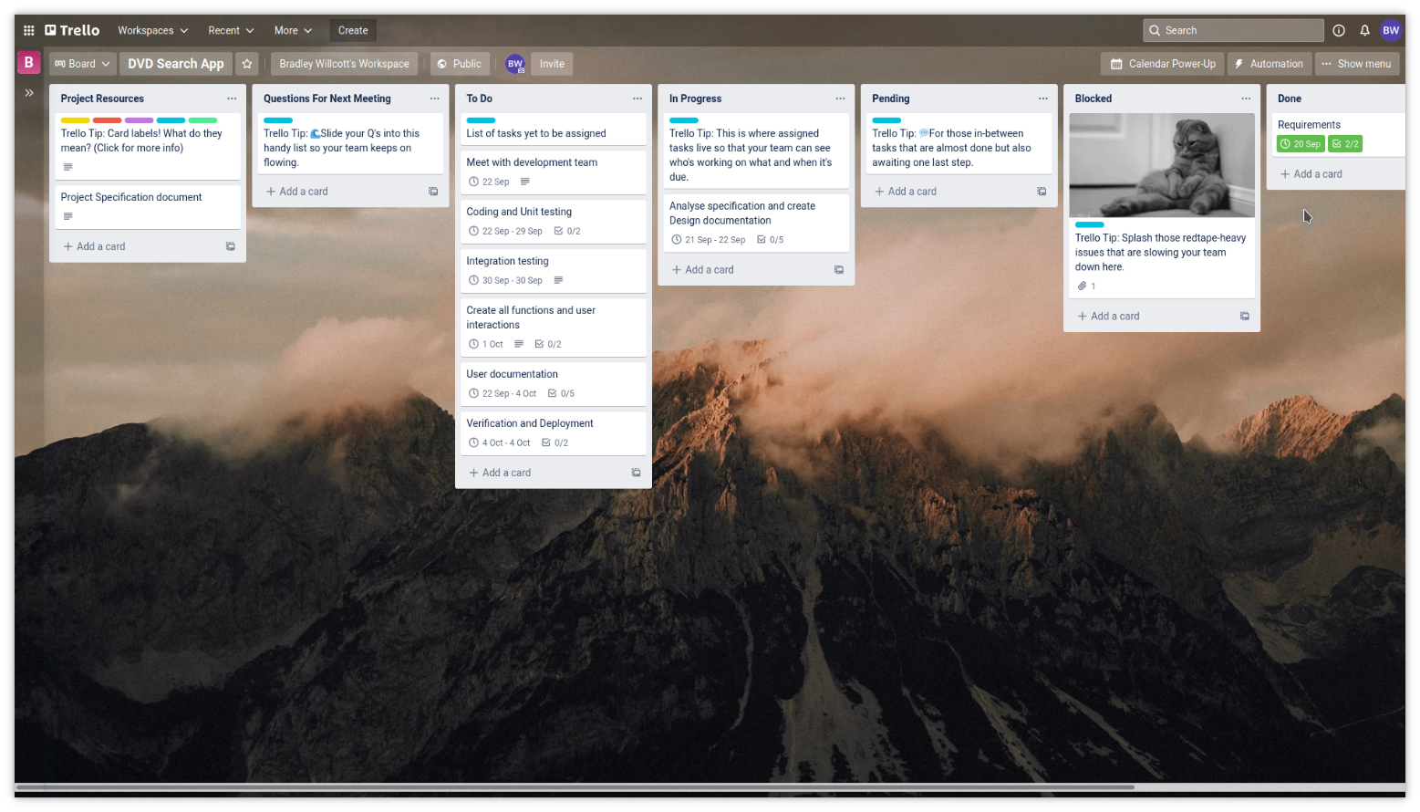

Figure 4 - Trello: Using it - C

# The Installation Package

## Method of creation

The installation package is a *zip* file (Windows 10 install) and a *tar.gz* file (Linux install), which is simply unpacked by the user into their preferred location. This file was created as part of the **Maven** build process for the application itself (refer to Figure 7).

## Configuration

The conjuration is all in one file: *config.properties*

* mysql.driver=com.mysql.jdbc.Driver
* mysql.url=jdbc:mysql://localhost:3306/DVD_Titles?useSSL=false
* mysql.username=root
* mysql.password=

# Deployment

## System Requirements

### Hardware

* Any CPU
* RAM – operating system requirements
* Storage - < 10Mb

### Software

* Java runtime/JDK 16+
* MySQL/MariaDB
* Database management software - phpMyAdmin

## Installation

The installation process is quite simple and straight forward.

1. Download the appropriate archive:
   1. Windows 10:  
      DeployAT-Project-1.0.0-deploy-win.zip
   2. Linux:  
      DeployAT-Project-1.0.0-deploy-linux.tar.gz
2. Unpack the archive into your preferred directory.
3. An *sql* file is provided for installing the database. Follow whatever procedures you normally follow for installing a new database.
4. The is a *config.properties* file that needs to be edited to reflect the system setup:
   1. The *mysql.url* string should be set to the IP/Internet address of the database server to be used
   2. The *mysql.username* and *mysql.password* should also be set to the correct values
   3. Note that this file should NOT be located where it can be accessed by other users
5. To run, execute the file as follows:
   1. Windows 10:  
      movies.bat
   2. Linux:  
      movies

**Note:**  
For the purposes of testing, I am using a copy of Windows 10 running within a Virtual Machine (Oracle VM VirtualBox) and accessing the same instance of XAMPP (running under Linux) as the Linux test. This required that the connection string be changed to the actual IP address of the computer (instead of “localhost”) and the username and password to a user account configured to have remote access from any IP address. This last has the potential to be a security risk if the computer was accessible from the Internet, which in this instance it is not.

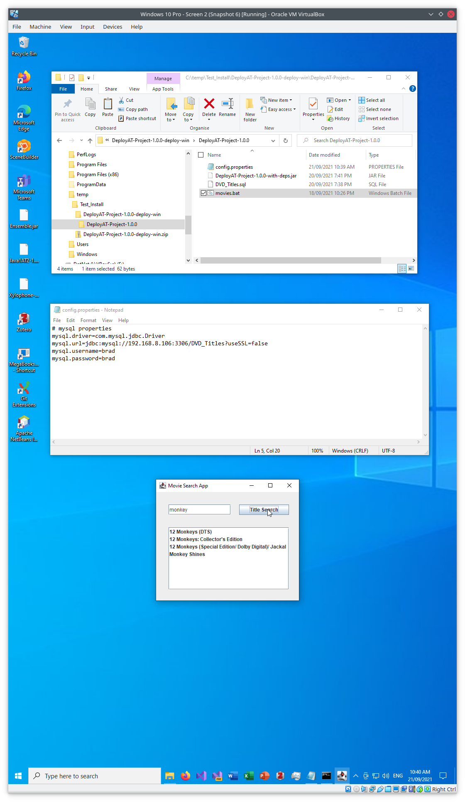

Figure 5 - Windows 10 Install

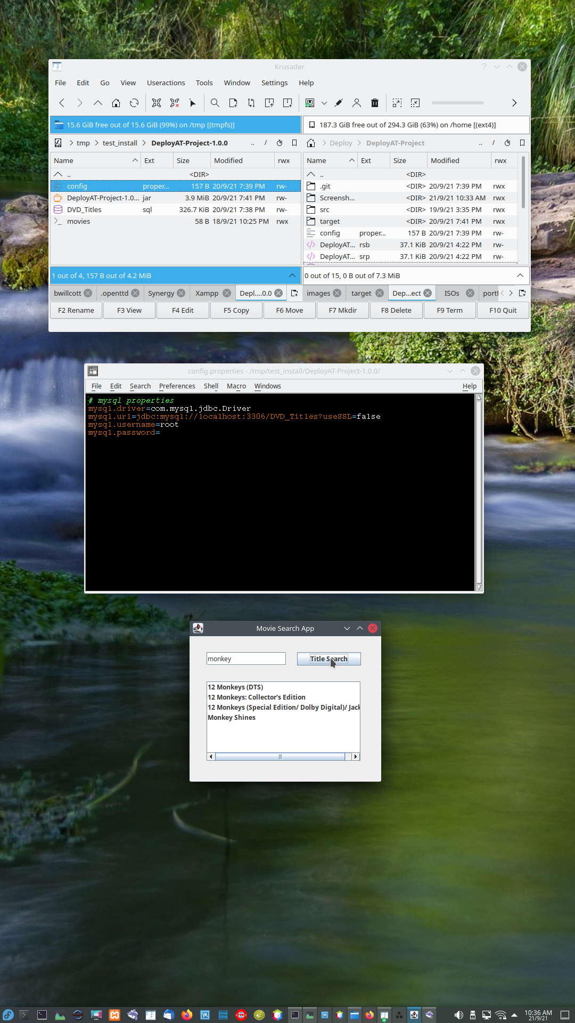

Figure 6 - Linux Install

## Un-installation

To uninstall the application, just delete the directory that you unpacked the archive into.

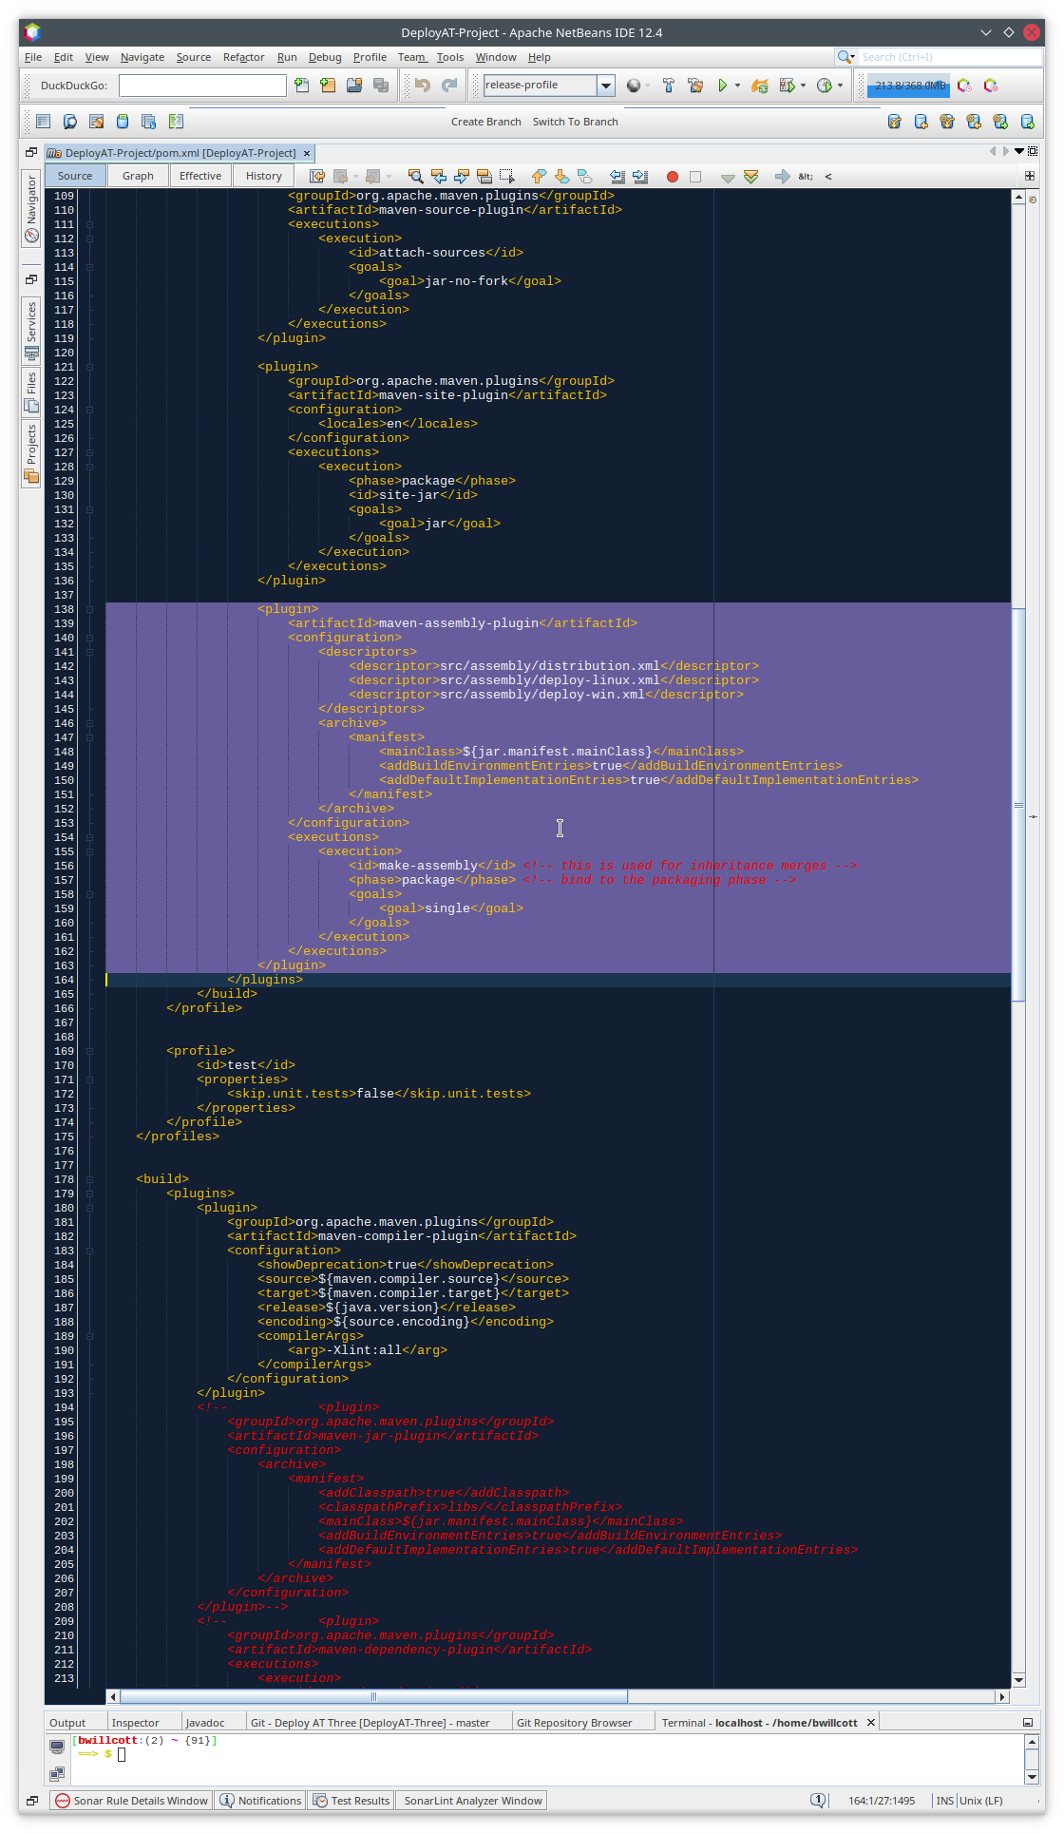

Figure - The pom.xml file - "maven-assemply-plugin"

# References

**There are no sources in the current document.**